|  |  |  |
| --- | --- | --- |
| Project Settings: <https://drive.google.com/open?id=1bIWSzxDlhNRyUOUX_9wq728ZlzKtD0T2mv1hEl6MYnA>  Please view project settings before start | | |

1. **Task Requirement / Description**
2. **Navigate to Task Area**
3. **UI Example**
4. **Programming Logic**
5. **Database**
6. **Changes to Commit ( developer to complete )**
   1. **Files / Folders to add to live site**
   2. **Database Changes to add to live site**
   3. **Developer notes / instructions for Project Manager**

**1. Task Requirement / Description**

Customer wants to hide some categories from the pdf catalog, please add a tick box option in the admin area for categories called “Hide from catalogue”

If a category is ticked then please hide it from the pdf catalogue

**2. Navigate to Task Area**



**3. UI Example**

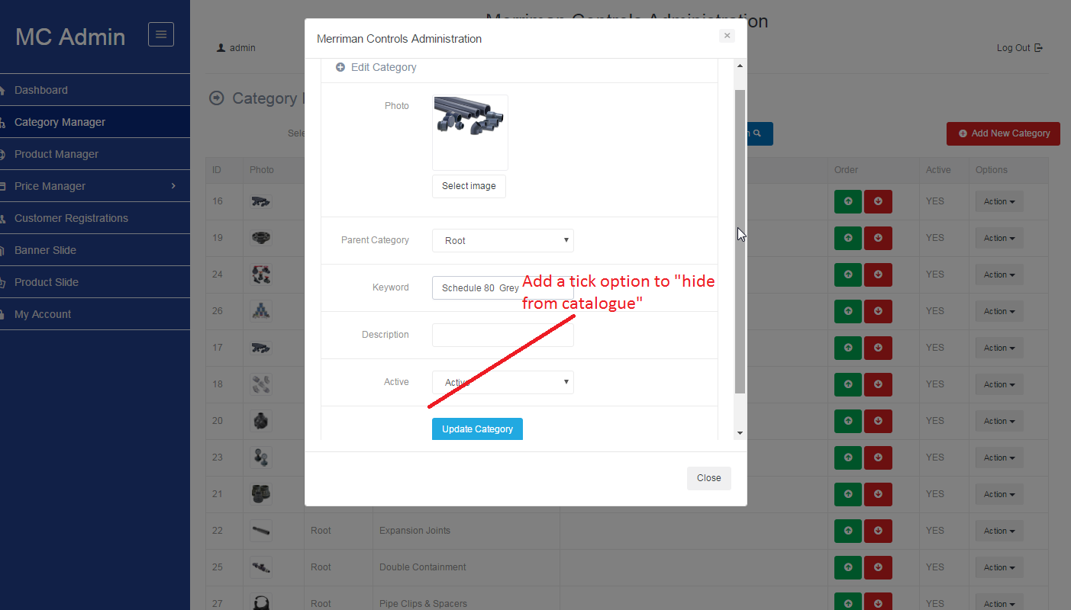

**4. Programming Logic**

In Pdf catalogue, if tick option is true then skip category

**5. Database**

Add field to the category table “isHiddenInPdf” default false

ALTER TABLE `category` ADD COLUMN `isHiddenInPdf` BOOLEAN NOT NULL DEFAULT 0 AFTER `sequence`;

**6. Changes to Commit ( Developer to Complete section 6a, 6b, 6c)**

This section is to help the Project Manager update the test site and live site. Please fill in the below area’s 6a, 6b and 6c, this is to inform the Project Manager as to what changes were made and needed to add update the live site

**6a. Files / Folders to add to live site**

Please add to the below table a list of files or folders that the Project Manager will need to upload to the live site.

|  |  |  |  |
| --- | --- | --- | --- |
| Folder Name: |  | | |
| File Name | File Name | File Name | File Name |
|  |  |  |  |
|  |  |  |  |
|  |  |  |  |

|  |  |  |  |
| --- | --- | --- | --- |
| Folder Name: |  | | |
| File Name | File Name | File Name | File Name |
|  |  |  |  |
|  |  |  |  |
|  |  |  |  |

|  |  |  |  |
| --- | --- | --- | --- |
| Folder Name: |  | | |
| File Name | File Name | File Name | File Name |
|  |  |  |  |
|  |  |  |  |
|  |  |  |  |

**6b. Database Changes to add to live site**

Please add below any db changes or db script code the Project Manager will need to add to the live site database

**6c. Developer notes / instructions for Project Manager**

Please add here any instructions for the Project Manager to follow for updating the live site

Eg. 1. Please run db script

2. Please insert new data to db

3. Then update files in live site

**END**